Project Proposal

**Body Modifications Appointments (BMA)**

**A website for managing appointments for tattooists, piercers, body modifiers and their clients.**

Joey Tatú

15015556

joey.tatu@student.ncirl.ie

BSc (Hons) in Computing – Software Development

October 2019

Contents

Acronyms 3

1. Objectives 3

2. Background 3

3. Technical Approach 4

4. Special resources required 5

5. Project Plan 5

6. Technical Details 5

7. Evaluation 6

# Acronyms

BMA – Body Modifications Appointments  
Artist – a tattooist, piercer or body modifier  
Client – a customer of the artist  
User – either an artist or a client  
Shop – a shop that does tattoos, piercings and/or body modifications.

# 1. Objectives

The objective of this Project is to create a website for artists and their clients to manage appointments and bookings. Clients will also be able to rate the artists and shops.

There are two types of accounts, one for artists and one for clients.The artists can choose to act as as shop or themselves. A shop can be linked to the artist.

Two databases will be created. The types of databases are:

1. For the users’ profile and personal information or the shop information.
2. For the appointments generated by the artists and clients.

These databases will be encrypted so that the general public will not be able to view it.

Reviews of artists and/or shops will be generated by the clients. These will be on the artist’s and shop’s pages. The artist or shop can delete comments as they wish.

Clients will need to have one confirmed booking, where the end time has passed to create a review of that particular artist and/or shop (i.e. to confirm they have gone to the appointment).

The website will automatically generate uncornfirmed appointments for when a client has booked an appointment at regular. These will be generated when (e.g.) a client books the 15th of every month for more than 3 months, but doesn’t book the following month. The system will notify the artist and client and keep the appointment for 7 days.

The client can confirm or deny this appointment. If they confirm, the uncornfirmed appointment changes to a regular appointment. If they deny, the 7 day wait is stopped at this point.

Standard website languages such as HTML, CSS, JavaScript, jQuery will be used to create the website. Artificial intelligence will be used to automate the appointments. It is expected Java or a similar language will be used to create this.

# 2. Background

“The idea was born in early 2018 when I was on a site called Inked-Up.com.” This site is specifically for men with body modifications. The website feels as if it’s catering to a very specific niche and it has very little else to offer. I was using the site extensively myself, as it’s an interest of mine. The site was heavily coloured and with dark colours and it felt as if it hasn’t been updated in a very long time. I felt as if the server for the site was a clunky old thing that people kicked if it failed ti get it working again. It feels very outdated and lacking interest. (Tatú, 2018)

“In 2018, I wanted to create a mobile application to not be in direct competetion with Inked-Up.com. But after talking to my tattooed and pierced friends, not many had heard about Inked-Up.com or didn’t like how “adult” it seemed, or how it was directed at men-for-men as it felt more like a dating site instead of a social networking site. I wanted to create a website for people with tattoos and piercings that grandparents would be comfortable with, knowing their grandkids where on this site, and to be inclusive of everyone.” (Tatú, 2018)

“I wanted a social networking site where everyone is welcome. Seemingly, the likes of Facebook, Instagram, Twitter, Tumblr and Flickr all have their own niche audienience and users. Why does it seem like tattooed and pierced people need to use a combination of these to be socialable?” (Tatú, 2018)

“With that, the idea of Social Modifications was born.” (Tatú, 2018) Sadly, this fell flat in January 2019. I became overwhelmed with other projects and was burnt out. Also, I didn’t have the facilities to create an Android application.

I found that when I was booking tattoo appointments, I felt it was a little more complicated than it needed to be, trying to contact the artist or the shop. Delays in communcation were present. There is also an issue with people booking appointments, not paying a deposit and not showing up, wasting the artist’s time.

To remedy this, I thought about creating BMA. With BMA the artist can tell the system what days and times they work and then clients can book a date and time when the artist is free. Clients will also be able to rate the artist and/or shop the artist works in and leave them a review.

# 3. Technical Approach

“In order to do this project, I will need to complete the Requirements Specifications. Based on previous projects, it’s best to set goals now and in the requirements, than trying to fix them at a later stage. Over the next few weeks, I will begin creating the prototype and preparing for the Mid-Point Presentation and then further develop this after.” (Tatú, 2018)

For version control, I will be using GitHub and Git Bash (Tatú, 2018) (<https://github.com/JoeyTatu/SoftwareProject>)

I wish to do some Java, JavaScript and jQuery refresher online courses. I feel this will be very beneficial for the project. If I need to learn new languages, I will research on how to do this.

“I will be using a mix of Kanban and Scrum (agile) methodologies as I will be able to lay out what is needed for the project, to keep myself organised and on-track, and to adjust to my supervisor’s feedback where needed.” (Tatú, 2018)

# 4. Special resources required

This project will be completed online, as much as possible. The reason for this is that I don’t have a personal computer with a large RAM to asssit me. “I suspect I will be using Amazon Web Services or a cheaper alternative.” (Tatú, 2018)

# 5. Project Plan

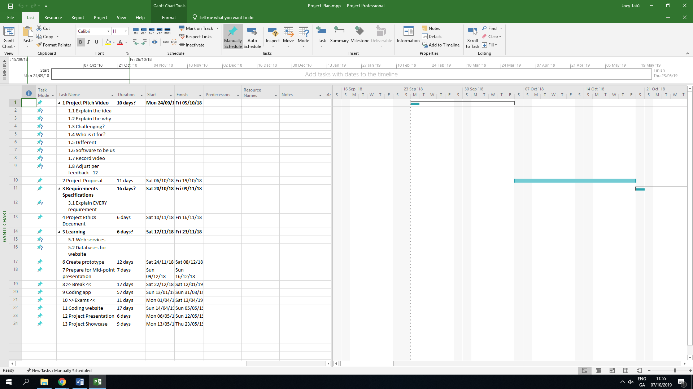

“This is currently the Project Plan. This will be updated on a regular basis and especially after I complete the Requirements Specifications.” (Tatú, 2018)

# 6. Technical Details

“The standard Web design coding such as HTML, CSS, XML, JavaScript, etc., will be used along with SQL” (Tatú, 2018) Java will also be used for the automated appointments.  
  
“I am very familiar with web design coding and SQL coding from previous projects in college and with personal projects.” (Tatú, 2018)

# 7. Evaluation

For testing, I will be generating both a artist and a client account, and testing how the artist sets the booking times and how the client books the appointments and leaves reviews. I will also be “booking” appointments once a month for in four of the months, to see the automated appointment being generated in month five.

“I will also be doing API checks. I will also be doing JUnit testing to test how the website responds to different environments”. (Tatú, 2018)

# References

Tatú, J., 2018. *Social Modifications,* Dublin: s.n.